SEG Awards Level 2

Motor Vehicle Studies

Underpinning Knowledge Evidence Record

T/601/5527 Knowledge of Motorcycle Fuel, Ignition, Air and Exhaust System Units and Components

Learners Name
SEG Awards Registration Number
Centre Name
Assessor 1 Name
Assessor 2 Name

DECLARATION OF AUTHENTICITY

This declaration must be completed and signed by the learner and countersigned by the tutor / assessor and covers all evidence submitted for moderation.

Learner Name
Unique Learner Number (ULN) |  | SEG  Learner Reg. ID
Qualification Title
Centre Name

Learner statement of authenticity

Before signing please read the guidance below.

I confirm, that the attached assignment / portfolio is all my own work and does not include any work completed by anyone other than myself. I have completed the assignment / portfolio in accordance with SEG Awards’ instructions and within the time limits set by my centre.

Signature |  | Date

Centre confirmation of authenticity

On behalf of …………………………………….(insert centre name), I confirm that the above mentioned learner, to the best of my knowledge, is the sole author of the completed assignment / portfolio attached, and the assessments have been completed under the required conditions.

Signed |  | Date
Name
Title

Guidance for Learners

You have been asked to sign this Declaration of Authenticity and place it at the front of your portfolio or course work assessment. It confirms that the work you have submitted for assessment is your own and that you have not copied it from someone else or allowed another learner to copy it from you.

When preparing any course work it is good practice to undertake research using information from published sources. If you quote directly from these sources then this must be indicated in your work by using quotation marks and referencing the document from which the quotation was taken. You must then comment in your own words on any ideas expressed.

Assessors, internal verifiers and SEG Awards’ external moderators and verifiers are subject specialists who can spot the use of published materials that may be passed as your own words or ideas.
If you do copy words from a published source and do not indicate their reference you will be committing plagiarism. This is considered a form of cheating and may result in your assessment being declared void.

Contents

Task No | Title | Assessment Criteria
1 | Fuel system components | 1.1, 1.2, 1.3, 1.5
2 | Ignition system components | 2.1, 2.2, 2.3, 2.4, 2.5
3 | Air supply and exhaust systems | 3.1, 3.2, 3.3, 3.5
4 | Check and replace systems | 4.1, 4.2, 4.3, 4.4

Task 1 – Fuel system components | Assessment Criteria 1.1, 1.2, 1.3, 1.5

Label the fuel system components
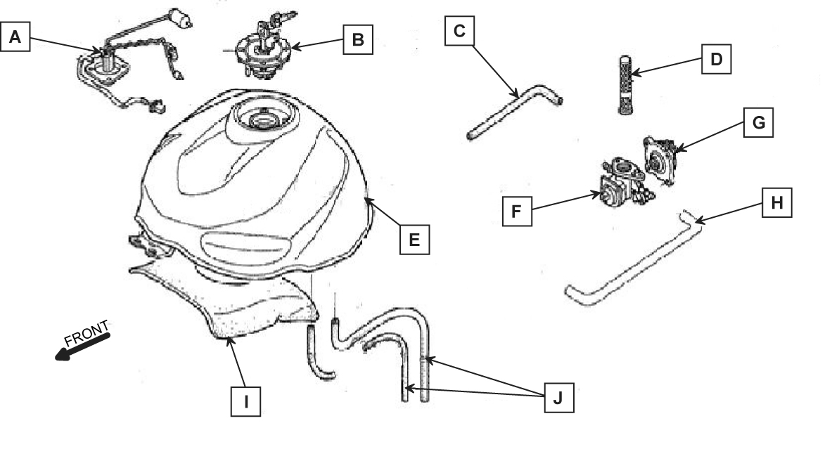
Label the fuel system components and briefly describe their construction and operation
Component | Construction and operation
A
B
C
D
E
F
G
H
I
J

Identify and explain the operation of these motorcycle fuel system components, stating differences between them.
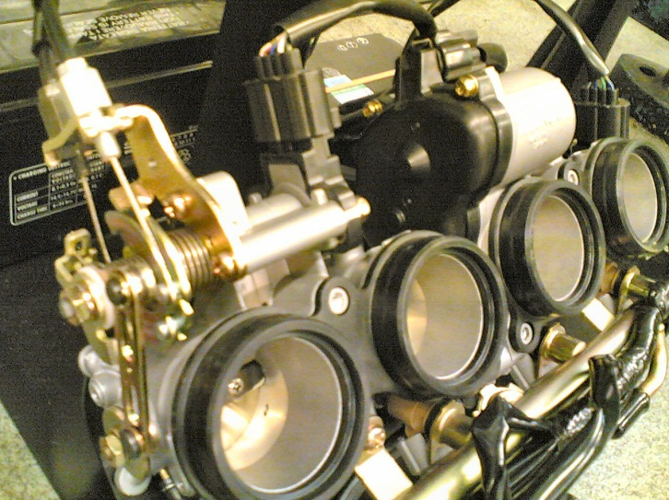
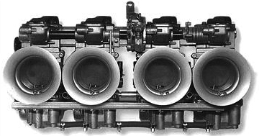
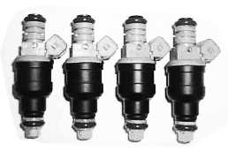

Describe what is meant by following engineering terms
Properties of fuels
Combustion processes
Exhaust gas constituents

Task 2 – Ignition system components | Assessment Criteria 2.1, 2.2, 2.3, 2.4, 2.5

Label the ignition system components
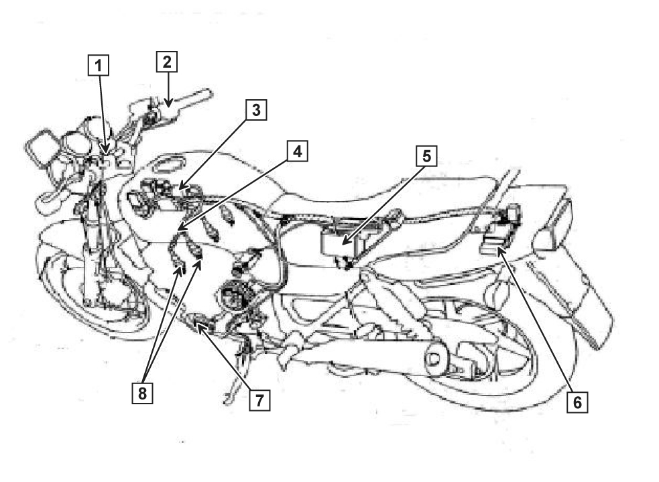
Label the ignition system components and briefly describe their construction and operation
Component | Construction and operation
1
2
3
4
5
6
7
8

Identify and explain the operation of these motorcycle ignition system components, stating differences between them.
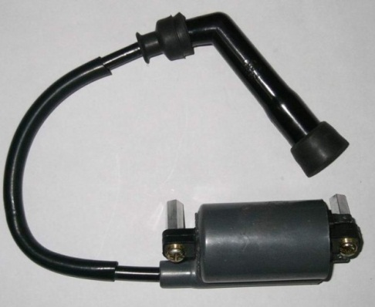
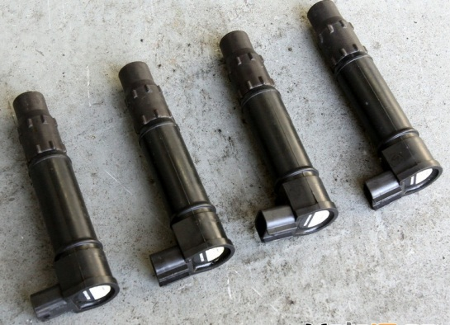
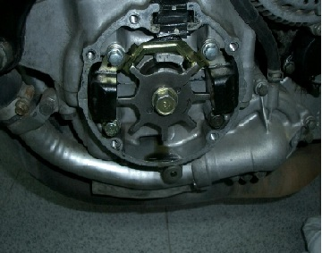
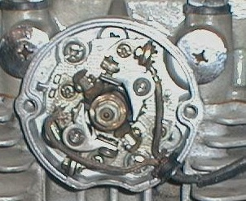

Describe what is meant by the following terms
Flame travel
Ignition timing

Task 3 – Air supply and exhaust systems | Assessment Criteria 3.1, 3.2, 3.3, 3.5

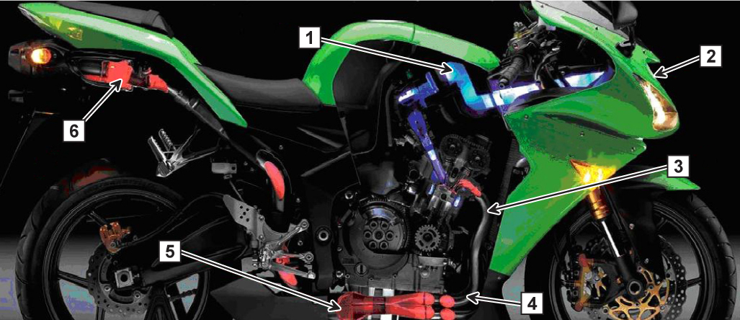
Briefly describe the construction and operation of the labelled intake and exhaust system components
Component | Construction and Operation
1
2
3
4
5
6

Identify and explain the operation of these motorcycle air supply and exhaust system components, stating differences between them.
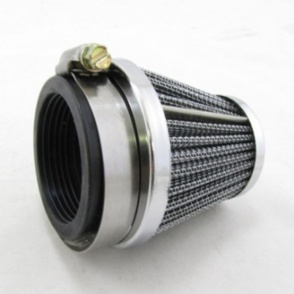
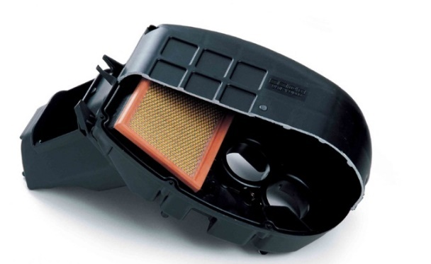
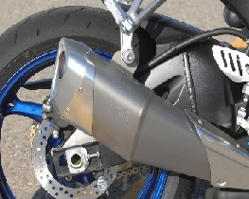
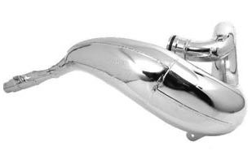
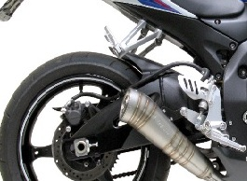

Describe the following engineering terms and how they affect motorcycles
Sound absorption
Reduction of harmful emissions

Task 4 – Check and replace systems | Assessment Criteria 4.1, 4.2, 4.3, 4.4

Describe how to remove, test, evaluate and replace the following system/components
Fuel system/components
Air intake system/components
Ignition system/components
Exhaust system/components

Give at least 3 examples of common fuel, ignition, air and exhaust system faults and describe the common causes for each
 | Fault 1 | Fault 2 | Fault 3
Carburettor
Ignition coil
Air box
Exhaust

Unless otherwise stated e.g. for some entry level qualifications, learners can work together but should identify sections which are their own work.

